**Practical No 3**

**Aim:** Create Data Source View using SSAS(SQL Server Analysis

Services.)

**Solution:**

1. Right click on Data Source View -> New Data Source View

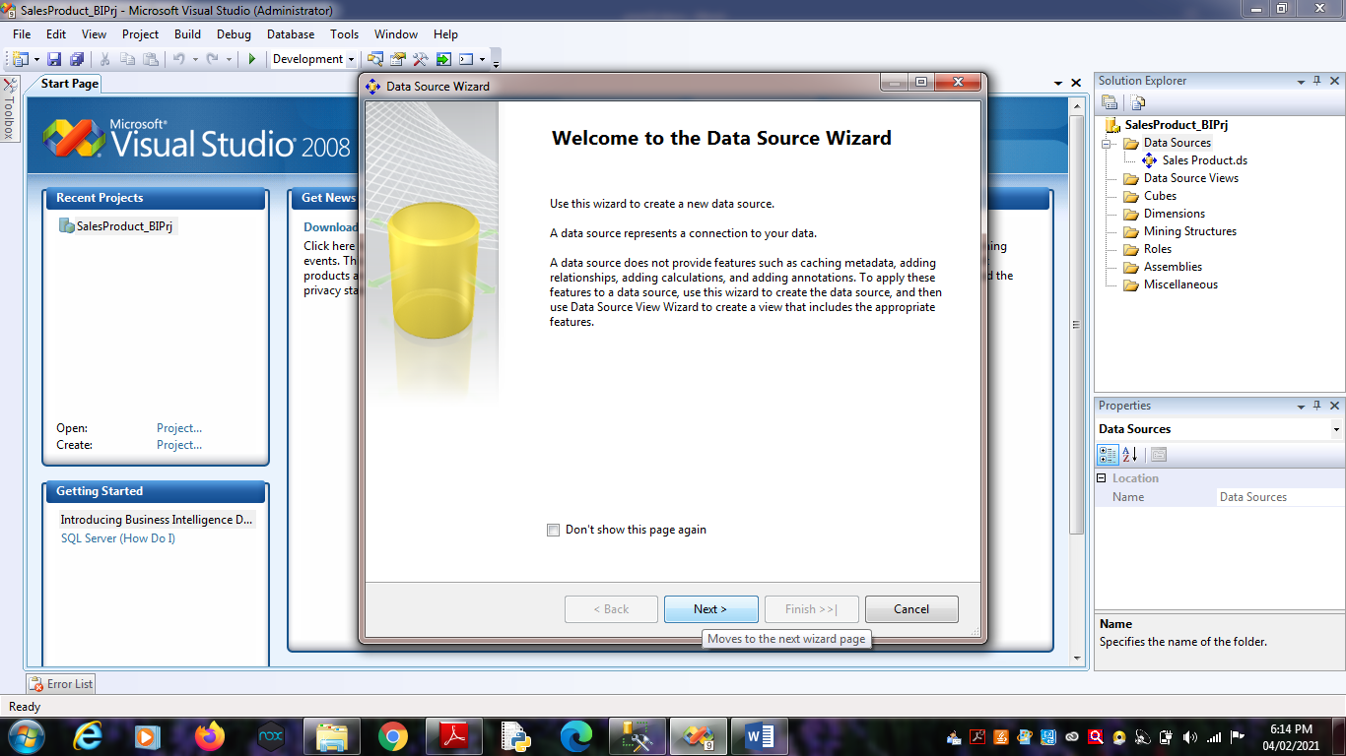Click on Next.

2. Click on Next.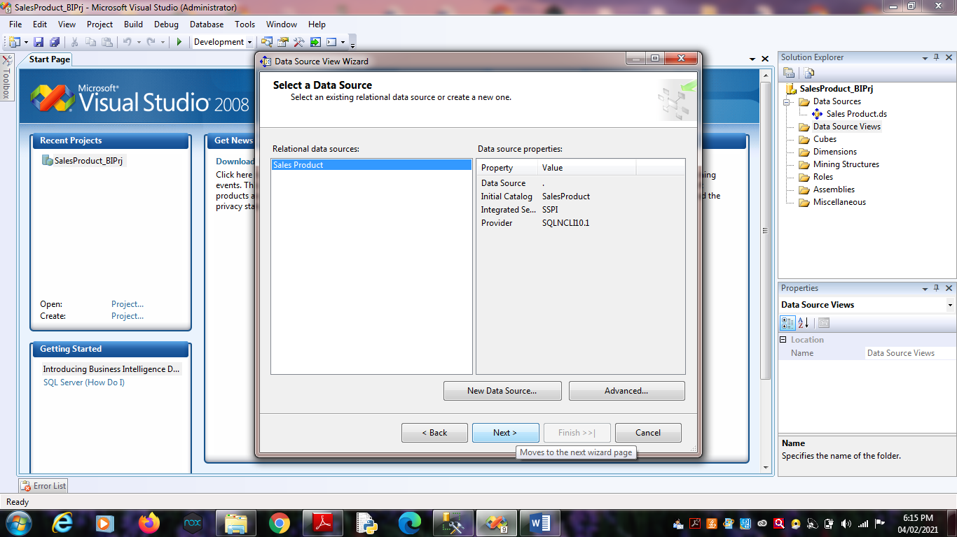

3. Select Tables and Views.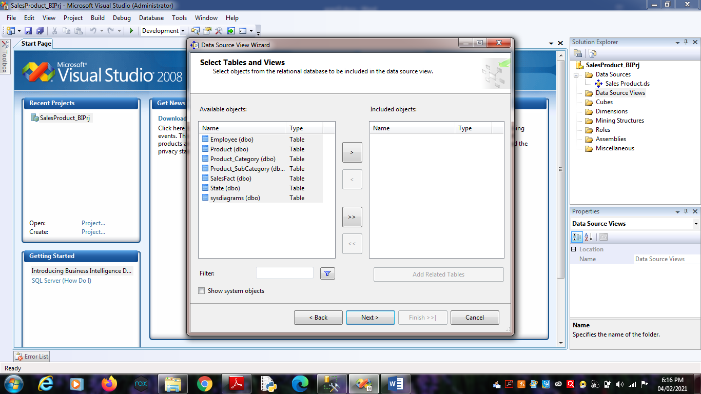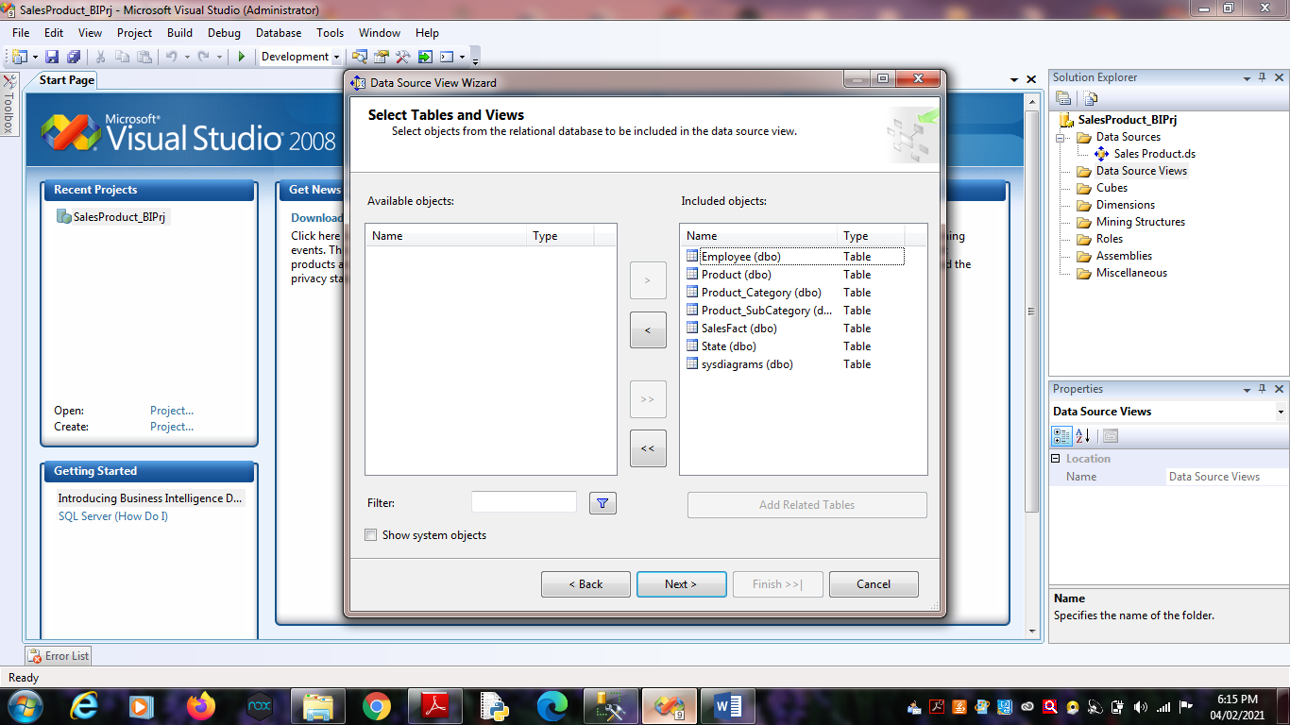 Click on Finish.

4. Finally, we will get the Data Source View like :